Release and Consent of Information and Photograph

I hereby _______________________________________________________give
Island Liaison, Inc. my permission to use and release my name for photograph, annual report, website, displays at cultural events, video image, voice recording information, testimonial, and related experiences.

Your personal information will be kept confidential.

Print Name ________________________________________________________

Signature _________________________________________________________

Date _____________________________________

* IF SUBJECT IS A MINOR (ages 15 to 17)

I represent that I am the parent or legal guardian of the Minor and that I have full authority to execute the Consent and Release on behalf of the Minor. I understand and agree to the terms set forth above

Print Name of Parent/Legal Guardian ___________________________________

Signature of Parent/Legal Guardian _____________________________________

Date ______________________________________

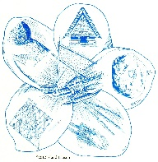
Island Liaison, Inc.
4119 E Monte Vista Rd., Phoenix, AZ 85008-3114
E: info@islandliaison.org
www.islandliaison.org

